
MANAV RACHNA INTERNATIONAL SCHOOL
NOIDA

Project Report
On
Pharmacy Management System
FOR
CBSE 2020 Examination
{As a part of Computer Science (New) Course-083}

Submitted By:-
Tanishq Rai & Vansh Chauhan
XII – Newton
Roll No.

Under The Guidance Og
Certificate

This is to certify that the Project/Dissertation entitled ______________ is a bonafide work done by __________ and ________________of class XII Session 2019-20 in partial fulfillment of CBSE’s AISSCE Examination 2020 and has been carried out under my direct supervision and guidance. This report or a similar report on the topic has not been submitted for any other examination and does not form a part of any other course undergone by the candidate.

_________________ _______________
Signature of Students Ms. Rakhi Garg
Faculty

________________ _______________
Signature of Invigilator Signature of Principal

Acknowledgement

We gratefully acknowledge the valuable guidance and support given to me by my teacher Ms. Rakhi Garg in successfully completing my project report. This project gave me a clear insight into real world business situation and gave me ample opportunities to apply me theoretical knowledge to practical situations. We would also like to thank our classmates for their suggestion and support in completing this project.

Index

Serial No. | Topic | Page No.
1 | Certificate | 3
2 | Acknowledgement | 4
3 | Introduction | 6
4 | Objective And Scope Of The Project | 7
5 | Problem Definition And Analysis | 8
6 | System Implementation | 9
7 | System Requirements | 10
8 | Salient Features | 11
9 | Code Of The Project | 12
10 | Database Structure | 38
11 | Output | 39
12 | Scope Of Improvement | 41
13 | Bibliography | 42

Introduction

This project aims at helping out fellow pharmacist to keep a record of their earnings.

Objective And Scope Of The Project

The main objective of the project is to help pharmacist keep a record of the medicine the sold and at what rate, the discount given.

Problem Definition And Analysis

Elderly people are finding less and less things to do in their time. So basically this game is gonna give them something to do in their free time.

System Requirements

- Main Processor: intel Pentium or above

- Hard Disk: 25 MB or greater

- RAM: 4 GB RAM or greater

- Operating System: Windows (10 Home / Professional)

- Language: Python

Salient Features

- The user can search for an item
- User can update the credentials of item
- User can ad items to the table

Code Of Project
from tkinter import *
from tkinter import messagebox
import os

f=open("database.txt",'a+')
root = Tk()
root.title("Pharmacy Managment System")
root.configure(width=1500,height=600,bg='gold')
var=-1

def additem():

global var
num_lines = 0
f10 = open("database.txt", 'r')

for line in f10:
num_lines += 1
var=num_lines-1

e1= entry1.get()
e2=entry2.get()
e3=entry3.get()
e4=entry4.get()
e5=entry5.get()

f.write('{0} {1} {2} {3} {4}\n'.format(str(e1),e2,e3,str(e4),e5))

entry1.delete(0, END)
entry2.delete(0, END)
entry3.delete(0, END)
entry4.delete(0, END)
entry5.delete(0, END)

def deleteitem():

e1=entry1.get()

f = open(r"database.txt")
working = open(r"database2.txt", "w")

for line in f:
if str(e1) not in line:
working.write(line)

os.remove(r"database.txt")
os.rename(r"database2.txt", r"database.txt")

f.close()
working.close()

entry1.delete(0, END)
entry2.delete(0, END)
entry3.delete(0, END)
entry4.delete(0, END)
entry5.delete(0, END)

def firstitem():

global var
var=0
f.seek(var)
c=f.readline()
v=list(c.split(" "))
entry1.delete(0, END)
entry2.delete(0, END)
entry3.delete(0, END)
entry4.delete(0, END)
entry5.delete(0, END)
entry1.insert(0,str(v[0]))
entry2.insert(0,str(v[1]))
entry3.insert(0,str(v[2]))
entry4.insert(0,str(v[3]))
entry5.insert(0,str(v[4]))

def nextitem():

global var
var = var + 1
f.seek(var)

try:
c=f.readlines()
xyz = c[var]
v = list(xyz.split(" "))
entry1.delete(0, END)
entry2.delete(0, END)
entry3.delete(0, END)
entry4.delete(0, END)
entry5.delete(0, END)
entry1.insert(0, str(v[0]))
entry2.insert(0, str(v[1]))
entry3.insert(0, str(v[2]))
entry4.insert(0, str(v[3]))
entry5.insert(0, str(v[4]))

except:
messagebox.showinfo("Title", "SORRY!...NO MORE RECORDS")

def previousitem():

global var
var=var-1
f.seek(var)
try:

z = f.readlines()
xyz=z[var]
v = list(xyz.split(" "))
entry1.delete(0, END)
entry2.delete(0, END)
entry3.delete(0, END)
entry4.delete(0, END)
entry5.delete(0, END)

entry1.insert(0, str(v[0]))
entry2.insert(0, str(v[1]))
entry3.insert(0, str(v[2]))
entry4.insert(0, str(v[3]))
entry5.insert(0, str(v[4]))

except:
messagebox.showinfo("Title", "SORRY!...NO MORE RECORDS")

def lastitem():

global var

f4=open("database.txt",'r')

x=f4.read().splitlines()
last_line= x[-1]
num_lines = 0

f8 = open("database.txt", 'r')

for line in f8:
num_lines += 1
var=num_lines-1
print(last_line)

try:
v = list(last_line.split(" "))
entry1.delete(0, END)
entry2.delete(0, END)
entry3.delete(0, END)
entry4.delete(0, END)
entry5.delete(0, END)

entry1.insert(0, str(v[0]))
entry2.insert(0, str(v[1]))
entry3.insert(0, str(v[2]))
entry4.insert(0, str(v[3]))
entry5.insert(0, str(v[4]))

except:
messagebox.showinfo("Title", "SORRY!...NO MORE RECORDS")

def updateitem():

e1 = entry1.get()
e2 = entry2.get()
e3 = entry3.get()
e4 = entry4.get()
e5 = entry5.get()

f1 = open(r"database.txt")
working = open(r"database2.txt", "w")

for line in f1:
if str(e1) not in line:
working.write(line)

else:
working.write('{0} {1} {2} {3} {4}'.format(str(e1), e2, e3, str(e4), e5))

os.remove(r"database.txt")
os.rename(r"database2.txt", r"database.txt")
f1.close()
working.close()

def searchitem():

i=0
e11 = entry1.get()
working = open(r"database.txt")

for line in working:
i=i+1
if str(e11) in line:
break

try:
v = list(line.split(" "))
entry1.delete(0, END)
entry2.delete(0, END)
entry3.delete(0, END)
entry4.delete(0, END)
entry5.delete(0, END)
entry1.insert(0, str(v[0]))
entry2.insert(0, str(v[1]))
entry3.insert(0, str(v[2]))
entry4.insert(0, str(v[3]))
entry5.insert(0, str(v[4]))

except:
messagebox.showinfo("Title", "error end of file")
working.close()

def clearitem():

entry1.delete(0, END)
entry2.delete(0, END)
entry3.delete(0, END)
entry4.delete(0, END)
entry5.delete(0, END)

label0= Label(root,text="PHARMACY MANAGEMENT SYSTEM ",bg="gold",fg="red",font=("Times", 30))

label1=Label(root,text="ENTER ITEM NAME",bg="red",relief="ridge",fg="white",font=("Times", 12),width=25)

entry1=Entry(root , font=("Times", 12))

label2=Label(root, text="ENTER ITEM PRICE",bd="2",relief="ridge",height="1",bg="red",fg="white",
font=("Times", 12),width=25)

entry2= Entry(root, font=("Times", 12))

label3=Label(root, text="ENTER ITEM QUANTITY",bd="2",relief="ridge",bg="red",fg="white",
font=("Times", 12),width=25)

entry3= Entry(root, font=("Times", 12))

label4=Label(root, text="ENTER ITEM CATEGORY",bd="2",relief="ridge",bg="red",fg="white",
font=("Times", 12),width=25)

entry4= Entry(root, font=("Times", 12))

label5=Label(root, text="ENTER ITEM DISCOUNT",bg="red",relief="ridge",fg="white",
font=("Times", 12),width=25)

entry5= Entry(root, font=("Times", 12))

button1= Button(root, text="ADD ITEM", bg="white", fg="black", width=20,
font=("Times", 12),command=additem)

button2= Button(root, text="DELETE ITEM", bg="white", fg="black", width =20,
font=("Times", 12),command=deleteitem)

button3= Button(root, text="VIEW FIRST ITEM" , bg="white", fg="black", width =20,
font=("Times", 12),command=firstitem)

button4= Button(root, text="VIEW NEXT ITEM" , bg="white", fg="black", width =20,
font=("Times", 12), command=nextitem)

button5= Button(root, text="VIEW PREVIOUS ITEM", bg="white", fg="black", width =20,
font=("Times", 12),command=previousitem)

button6= Button(root, text="VIEW LAST ITEM", bg="white", fg="black", width =20,
font=("Times", 12),command=lastitem)

button7= Button(root, text="UPDATE ITEM", bg="white", fg="black", width =20,
font=("Times", 12),command=updateitem)

button8= Button(root, text="SEARCH ITEM", bg="white", fg="black", width =20,
font=("Times", 12),command=searchitem)

button9= Button(root, text="CLEAR SCREEN", bg="white", fg="black", width=20,
font=("Times", 12),command=clearitem)

label0.grid(columnspan=6, padx=10, pady=10)

label1.grid(row=1,column=0, sticky=W, padx=10, pady=10)

label2.grid(row=2,column=0, sticky=W, padx=10, pady=10)

label3.grid(row=3,column=0, sticky=W, padx=10, pady=10)

label4.grid(row=4,column=0, sticky=W, padx=10, pady=10)

label5.grid(row=5,column=0, sticky=W, padx=10, pady=10)

entry1.grid(row=1,column=1, padx=40, pady=10)

entry2.grid(row=2,column=1, padx=10, pady=10)

entry3.grid(row=3,column=1, padx=10, pady=10)

entry4.grid(row=4,column=1, padx=10, pady=10)

entry5.grid(row=5,column=1, padx=10, pady=10)

button1.grid(row=1,column=4, padx=40, pady=10)

button2.grid(row=1,column=5, padx=40, pady=10)

button3.grid(row=2,column=4, padx=40, pady=10)

button4.grid(row=2,column=5, padx=40, pady=10)

button5.grid(row=3,column=4, padx=40, pady=10)

button6.grid(row=3,column=5, padx=40, pady=10)

button7.grid(row=4,column=4, padx=40, pady=10)

button8.grid(row=4,column=5, padx=40, pady=10)

button9.grid(row=5,column=5, padx=40, pady=10)
root.mainloop()

Database Structure

- database.txt
- database2.txx

OUTPUT
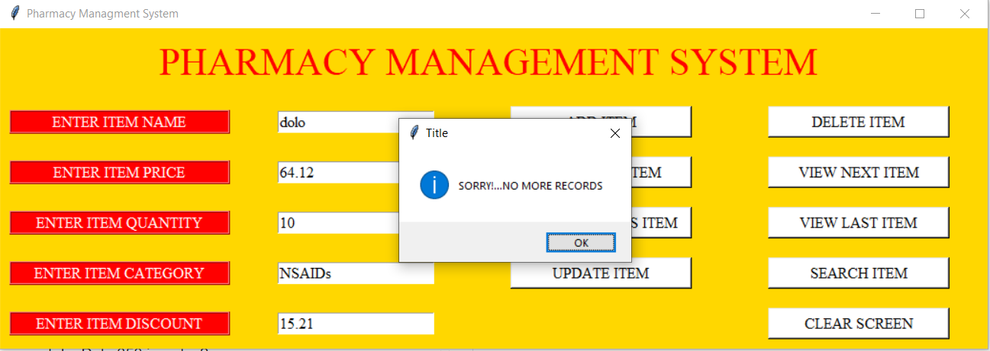
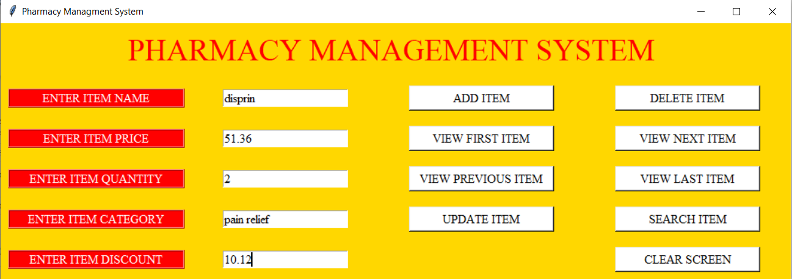
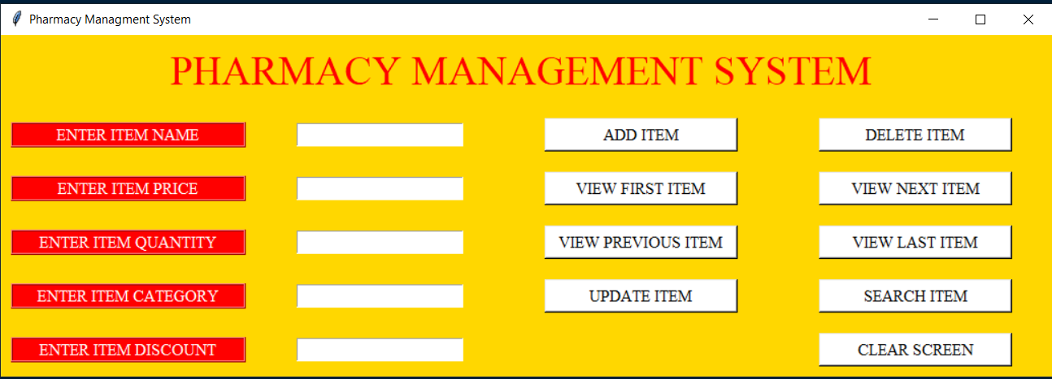

Scope Of Improvement

- The GUI can be more interactive
- List of medicine to be displayed as typing

Bibliography

- https://www.pygame.org/docs/
- Python Programing by Sumita Arora

